# TIC TAC TOE GAME C++

## A screen shot of a computer Description automatically generatedIntroducing the steps needed to complete the game.

# **Combo check.**

In this code I am checking out the winning combos. So, in this code I coded the horizontal, row and diagonal combo win.

# **Horizontal win.**

It does declare a diagonal win

# **Diagonal win.**

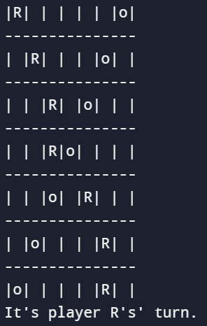

It doesn’t declare a diagonal win.

# **Row win**

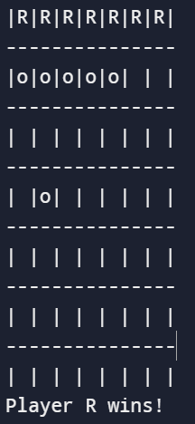

It does declare a diagonal win

# **Board constructor**

I call this the board constructor because it initialize the game board with empty spaces.

# **Print & display the board.**

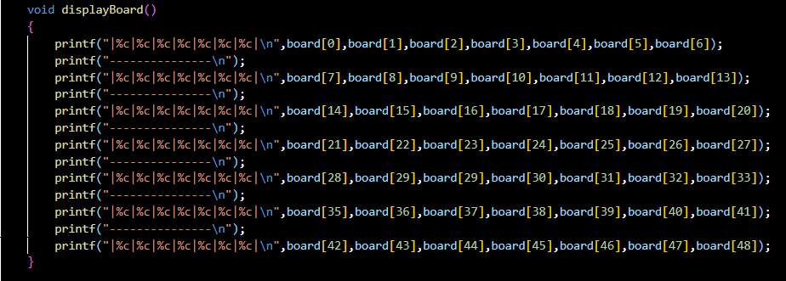

In this code I am basically printing out the layout of the board by using the “Printf” as it will display the board on the screen when I run it, as you can see from the board above.

# **Player winner**

It basically check if a player has won the game. It checks all possible winning combinations to determine if the specified player won.

# **Game class**

This code manages or handles the turns of the player either R or X, tracking the game board.

**Take turn.**

This code prompts the player either R or X to move by entering in an index and adds and update the index input by the player to the game.

**Game class function.**

This code does a lot. It check if the game has ended and also return true if the game has reached its end condition. This code also checks the winner by a player taking its turn.

**Main function**

This code basically Creates a game board and a game object, then runs a loop to play the game until it ends.